**2D CNN Architecture Model by Tuning Hyperparameters**

* **1st Test : 1a) Kernel Size**

|  |  |
| --- | --- |
| Kernel Size | 3x3 |
| No. Of Kernels | 1st Layer: 32 Kernels  2nd Layer: 64 Kernels  3rd Layer: 128 Kernels |
| Activation Function | ReLU |
| Dropout Layers | No Dropout Layers |
| FCs Layer | 1 Fully Connect Layers  Dense (128, activation = ReLU) |
| Regularization | No regularization |
| Max Pooling | First Max Pooling: (2x2)  Second Max Pooling: (2x2)  Third Max Pooling: (2x2) |
| No. of Control Layers | No Specific Control Layers |

* *Result and Observation:*

| **Epoch** | **Training Accuracy** | **Training Loss** | **Validation Accuracy** | **Validation Loss** |
| --- | --- | --- | --- | --- |
| 1 | 0.4490 | 1.2137 | 0.6606 | 0.8439 |
| 2 | 0.6732 | 0.8103 | 0.6709 | 0.9108 |
| 3 | 0.7171 | 0.7232 | 0.6921 | 0.8485 |
| 4 | 0.7447 | 0.6306 | 0.7211 | 0.8269 |
| 5 | 0.7560 | 0.6317 | 0.6897 | 0.8471 |
| 6 | 0.7920 | 0.5778 | 0.7526 | 0.6349 |
| 7 | 0.7825 | 0.5550 | 0.7526 | 0.6712 |
| 8 | 0.7876 | 0.5319 | 0.7800 | 0.5360 |
| 9 | 0.7957 | 0.5160 | 0.7855 | 0.5416 |
| 10 | 0.8181 | 0.4728 | 0.7439 | 0.6896 |
| 11 | 0.8112 | 0.4649 | 0.7722 | 0.5416 |
| 12 | 0.8151 | 0.4744 | 0.7989 | 0.5491 |
| 13 | 0.8237 | 0.4336 | 0.7628 | 0.6013 |
| 14 | 0.8312 | 0.4323 | 0.7863 | 0.5308 |
| 15 | 0.8448 | 0.4010 | 0.8201 | 0.4662 |
| 16 | 0.8323 | 0.4156 | 0.7698 | 0.6389 |
| 17 | 0.8457 | 0.4061 | 0.8288 | 0.4360 |
| 18 | 0.8519 | 0.3728 | 0.8115 | 0.5030 |
| 19 | 0.8630 | 0.3548 | 0.8303 | 0.4199 |
| ***20*** | ***0.8639*** | ***0.3499*** | ***0.8358*** | ***0.4453*** |

| **Class** | **Precision** | **Recall** | **F1-Score** | **Support** |
| --- | --- | --- | --- | --- |
| Glioma | 0.86 | 0.77 | 0.81 | 262 |
| Meningioma | 0.78 | 0.58 | 0.67 | 306 |
| No Tumor | 0.80 | 1.00 | 0.89 | 405 |
| Pituitary | 0.91 | 0.94 | 0.92 | 300 |
| **Accuracy** |  |  | **0.84** | 1273 |
| **Macro Avg** | 0.84 | 0.82 | 0.82 | 1273 |
| **Weighted Avg** | 0.84 | 0.84 | 0.83 | 1273 |

**AUC Score: 0.9674**

***Test Accuracy: 0.8358***

***Test Loss: 0.4453***

* *Graph:*

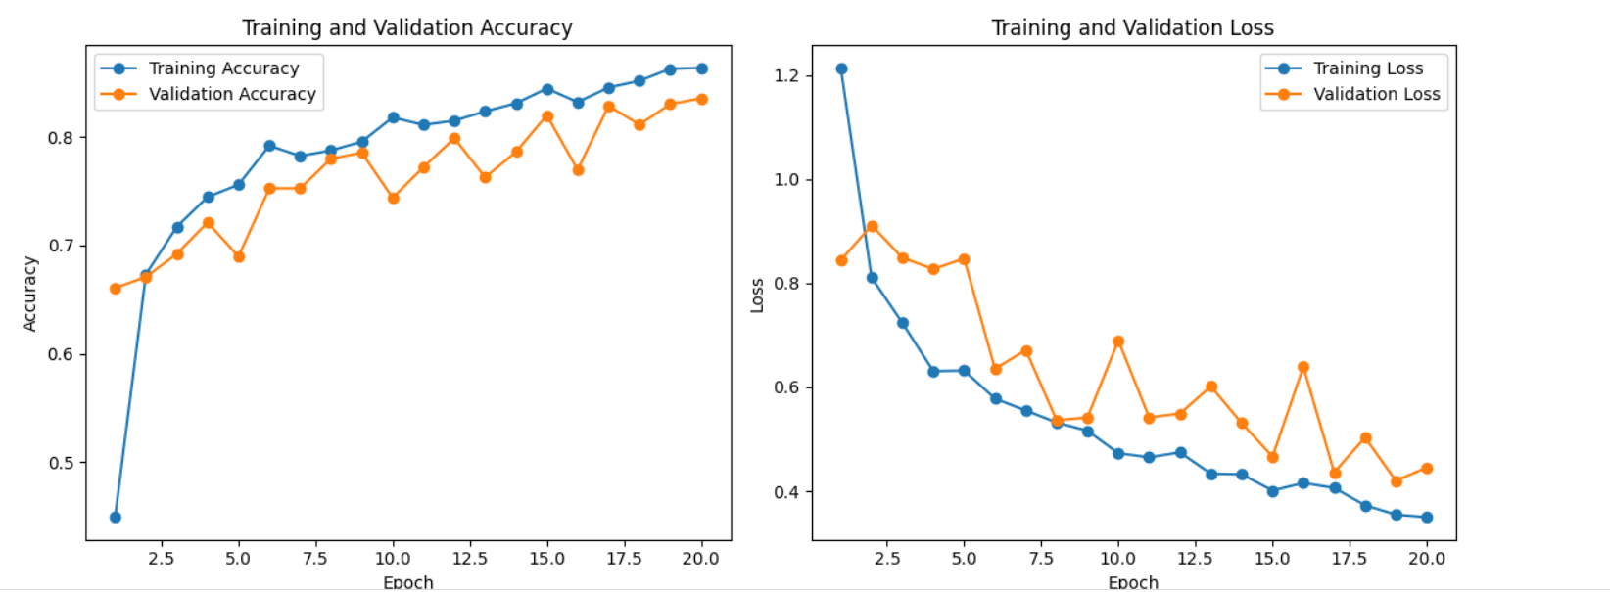

***1b) Kernel size = 5x5***

* *Result and Observation:*

| **Epoch** | **Training Accuracy** | **Training Loss** | **Validation Accuracy** | **Validation Loss** |
| --- | --- | --- | --- | --- |
| 1 | 0.4331 | 1.2289 | 0.5161 | 1.2299 |
| 2 | 0.6492 | 0.8558 | 0.6206 | 1.0130 |
| 3 | 0.7001 | 0.7537 | 0.7376 | 0.6222 |
| 4 | 0.7271 | 0.6828 | 0.7541 | 0.6416 |
| 5 | 0.7757 | 0.5794 | 0.7392 | 0.6850 |
| 6 | 0.7621 | 0.5852 | 0.7486 | 0.5819 |
| 7 | 0.7860 | 0.5366 | 0.7282 | 0.7074 |
| 8 | 0.7975 | 0.5222 | 0.7753 | 0.5546 |
| 9 | 0.7904 | 0.5222 | 0.7588 | 0.6238 |
| 10 | 0.8268 | 0.4544 | 0.7997 | 0.4652 |
| 11 | 0.8210 | 0.4632 | 0.7840 | 0.5464 |
| 12 | 0.8279 | 0.4427 | 0.8115 | 0.4461 |
| 13 | 0.8326 | 0.4175 | 0.8154 | 0.4319 |
| 14 | 0.8389 | 0.4101 | 0.8052 | 0.4793 |
| 15 | 0.8354 | 0.4183 | 0.8013 | 0.4738 |
| 16 | 0.8424 | 0.3978 | 0.8130 | 0.4435 |
| 17 | 0.8519 | 0.3853 | 0.8185 | 0.3964 |
| 18 | 0.8501 | 0.3869 | 0.8280 | 0.3923 |
| ***19*** | ***0.8507*** | ***0.3924*** | ***0.8366*** | ***0.3926*** |
| 20 | 0.8624 | 0.3548 | 0.8342 | 0.3675 |

| **Class** | **Precision** | **Recall** | **F1-Score** | **Support** |
| --- | --- | --- | --- | --- |
| Glioma | 0.86 | 0.71 | 0.77 | 262 |
| Meningioma | 0.67 | 0.70 | 0.69 | 306 |
| No tumor | 0.89 | 0.97 | 0.93 | 405 |
| Pituitary | 0.92 | 0.90 | 0.91 | 300 |
| **Accuracy** |  |  | 0.83 | 1273 |
| **Macro Avg** | 0.83 | 0.82 | 0.82 | 1273 |
| **Weighted Avg** | 0.84 | 0.83 | 0.83 | 1273 |

***AUC Score: 0.9662***

***Test Accuracy: 0.8366***

***Test Loss: 0.3926***

* *Graph:*

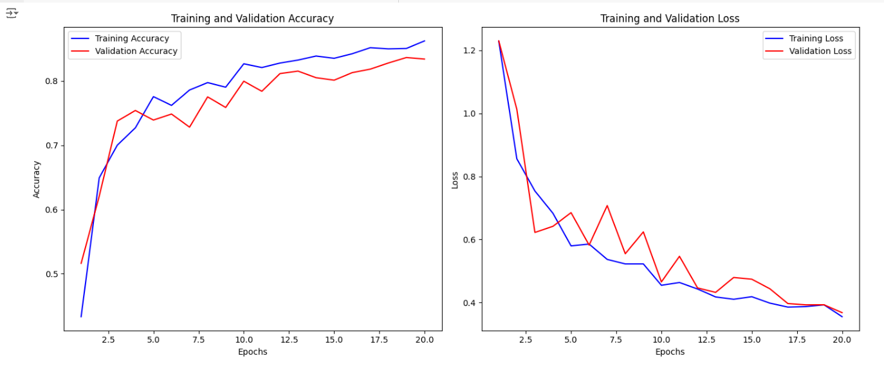

**1c) Kernel Size = 7x7**

* *Result and Observation:*

| **Epoch** | **Training Accuracy** | **Training Loss** | **Validation Accuracy** | **Validation Loss** |
| --- | --- | --- | --- | --- |
| 1 | 37.91% | 1.4267 | 66.61% | 1.0914 |
| 2 | 64.07% | 0.8966 | 65.59% | 0.8244 |
| 3 | 66.39% | 0.8315 | 70.15% | 0.8280 |
| 4 | 70.10% | 0.7524 | 72.03% | 0.7412 |
| 5 | 71.00% | 0.7284 | 70.15% | 0.8010 |
| 6 | 72.77% | 0.6719 | 68.19% | 1.0314 |
| 7 | 73.26% | 0.6499 | 70.62% | 0.6876 |
| 8 | 75.06% | 0.6311 | 73.76% | 0.6697 |
| 9 | 75.29% | 0.6043 | 73.84% | 0.5987 |
| 10 | 78.43% | 0.5517 | 73.84% | 0.6260 |
| 11 | 79.10% | 0.5293 | 79.50% | 0.5194 |
| 12 | 79.22% | 0.5258 | 76.20% | 0.6062 |
| 13 | 78.76% | 0.5300 | 76.83% | 0.5424 |
| 14 | 79.61% | 0.5191 | 75.81% | 0.6205 |
| 15 | 80.70% | 0.5036 | 79.97% | 0.5142 |
| 16 | 82.95% | 0.4543 | 79.18% | 0.5087 |
| ***17*** | ***81.15%*** | ***0.4661*** | ***83.66%*** | ***0.4134*** |
| 18 | 82.18% | 0.4574 | 80.44% | 0.4718 |
| 19 | 83.76% | 0.4177 | 80.28% | 0.4785 |
| 20 | 83.30% | 0.4184 | 82.72% | 0.4317 |

| **Class** | **Precision** | **Recall** | **F1-Score** | **Support** |
| --- | --- | --- | --- | --- |
| Glioma | 0.85 | 0.64 | 0.73 | 262 |
| Meningioma | 0.67 | 0.70 | 0.68 | 306 |
| No Tumor | 0.86 | 0.99 | 0.92 | 405 |
| Pituitary | 0.93 | 0.90 | 0.92 | 300 |
| **Accuracy** |  |  | **0.83** | 1273 |
| **Macro Avg** | 0.83 | 0.81 | 0.81 | 1273 |
| **Weighted Avg** | 0.83 | 0.83 | 0.82 | 1273 |

***AUC Score: 0.9583***

***Test Accuracy: 0.8366***

***Test Loss: 0.4134***

* *Graph:*

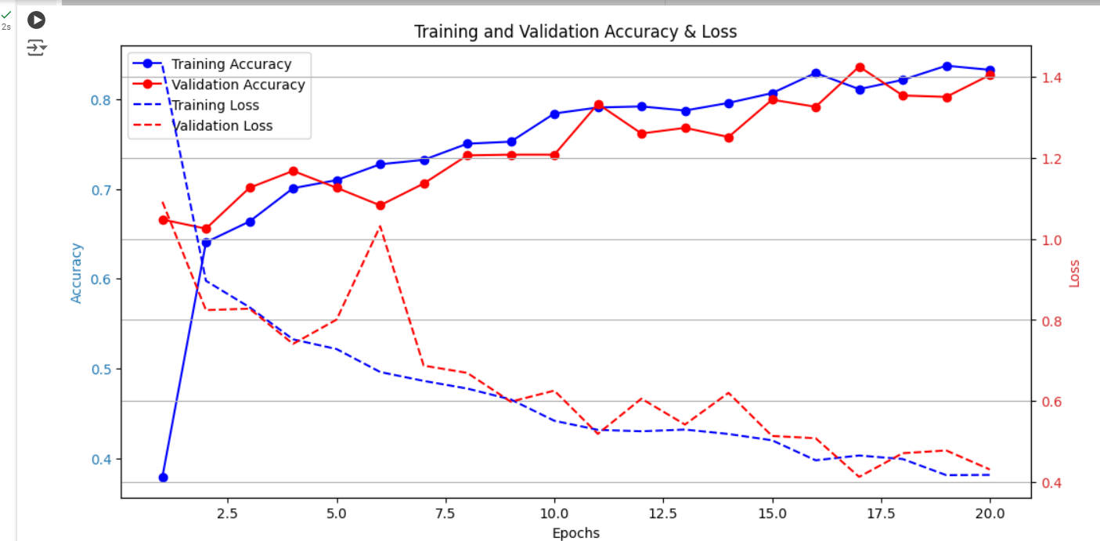

* ***2st Test : 2a) No. of Kernels in Layers***

|  |  |
| --- | --- |
| Kernel Size | 3x3 |
| No. Of Kernels | 1st Layer: 64 Kernels  2nd Layer: 128 Kernels  3rd Layer: 256 Kernels |
| Activation Function | ReLU |
| Dropout Layers | No Dropout Layers |
| FCs Layer | 1 Fully Connect Layers  Dense (128, activation = ReLU) |
| Regularization | No regularization |
| Max Pooling | First Max Pooling: (2x2)  Second Max Pooling: (2x2)  Third Max Pooling: (2x2) |
| No. of Control Layers | No Specific Control Layers |

* *Result and Observation:*

| ***Epoch*** | ***Training Accuracy*** | ***Training Loss*** | ***Validation Accuracy*** | ***Validation Loss*** |
| --- | --- | --- | --- | --- |
| 1 | 0.4224 | 1.3759 | 0.5892 | 1.0358 |
| 2 | 0.6733 | 0.8105 | 0.6999 | 0.7517 |
| 3 | 0.6817 | 0.7830 | 0.6874 | 0.9581 |
| 4 | 0.7095 | 0.7314 | 0.7148 | 0.8147 |
| 5 | 0.7344 | 0.6805 | 0.7211 | 0.7303 |
| 6 | 0.7445 | 0.6674 | 0.7007 | 0.7354 |
| 7 | 0.7406 | 0.6325 | 0.6874 | 0.8349 |
| 8 | 0.7710 | 0.5852 | 0.6976 | 0.9002 |
| 9 | 0.7858 | 0.5538 | 0.7769 | 0.5306 |
| 10 | 0.7846 | 0.5328 | 0.7620 | 0.5893 |
| 11 | 0.7990 | 0.5094 | 0.7541 | 0.6439 |
| 12 | 0.8053 | 0.4889 | 0.7989 | 0.4975 |
| 13 | 0.8069 | 0.4847 | 0.8036 | 0.4900 |
| 14 | 0.8161 | 0.4744 | 0.7793 | 0.5615 |
| 15 | 0.8205 | 0.4654 | 0.7903 | 0.5687 |
| 16 | 0.8172 | 0.4569 | 0.7824 | 0.4948 |
| 17 | 0.8312 | 0.4364 | 0.7730 | 0.6050 |
| 18 | 0.8369 | 0.4211 | 0.8068 | 0.4942 |
| ***19*** | ***0.8447*** | ***0.4041*** | ***0.8107*** | ***0.4898*** |
| 20 | 0.8477 | 0.3984 | 0.7785 | 0.5645 |

| ***Class*** | ***Precision*** | ***Recall*** | ***F1-Score*** | ***Support*** |
| --- | --- | --- | --- | --- |
| *Glioma* | *0.83* | *0.62* | *0.71* | *262* |
| *Meningioma* | *0.64* | *0.53* | *0.58* | *306* |
| *No Tumor* | *0.77* | *1.00* | *0.87* | *405* |
| *Pituitary* | *0.88* | *0.88* | *0.88* | *300* |
| ***Accuracy*** |  |  | *0.78* | *1273* |
| ***Macro Avg*** | *0.78* | *0.76* | *0.76* | *1273* |
| ***Weighted Avg*** | *0.78* | *0.78* | *0.77* | *1273* |
| ***AUC Score*** |  |  | *0.9467* |  |

***Test Accuracy: 0.8107***

***Test Loss: 0.4898***

* *Graph:*

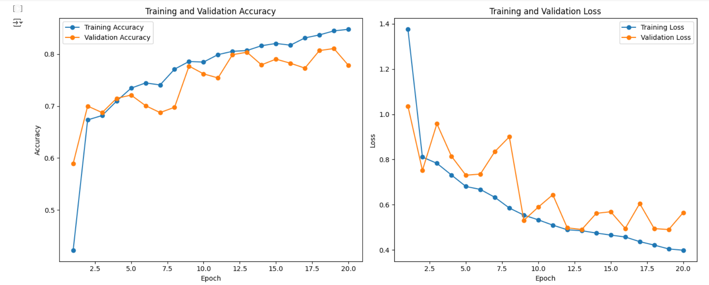

* ***2b Test (No. of Kernels in Layers)***

|  |  |
| --- | --- |
| No. Of Kernels | 1st Layer: 64 Kernels  2nd Layer: 64 Kernels  3rd Layer: 64 Kernels |

* *Result and Observation:*

| ***Epoch*** | ***Train Accuracy*** | ***Train Loss*** | ***Val Accuracy*** | ***Val Loss*** |
| --- | --- | --- | --- | --- |
| *1* | *0.4393* | *1.1941* | *0.5703* | *1.2285* |
| *2* | *0.6708* | *0.8090* | *0.6614* | *0.9776* |
| *3* | *0.7004* | *0.7454* | *0.7526* | *0.7190* |
| *4* | *0.7445* | *0.6485* | *0.7078* | *0.8014* |
| *5* | *0.7600* | *0.6217* | *0.7518* | *0.6962* |
| *6* | *0.7934* | *0.5287* | *0.6496* | *0.9830* |
| *7* | *0.7879* | *0.5315* | *0.7628* | *0.5863* |
| *8* | *0.8150* | *0.4824* | *0.7863* | *0.5657* |
| *9* | *0.8140* | *0.4695* | *0.7785* | *0.5344* |
| *10* | *0.8309* | *0.4388* | *0.7824* | *0.4966* |
| *11* | *0.8337* | *0.4373* | *0.7950* | *0.4999* |
| *12* | *0.8343* | *0.4119* | *0.7785* | *0.5828* |
| *13* | *0.8420* | *0.4039* | *0.7863* | *0.5352* |
| *14* | *0.8438* | *0.3985* | *0.7981* | *0.4853* |
| *15* | *0.8457* | *0.3952* | *0.8327* | *0.3957* |
| *16* | *0.8608* | *0.3559* | *0.7903* | *0.5115* |
| *17* | *0.8599* | *0.3620* | *0.8162* | *0.4325* |
| *18* | *0.8713* | *0.3300* | *0.8295* | *0.4108* |
| ***19*** | ***0.8562*** | ***0.3654*** | ***0.8382*** | ***0.3932*** |
| *20* | *0.8695* | *0.3352* | *0.8233* | *0.4478* |

| ***Class*** | ***Precision*** | ***Recall*** | ***F1-Score*** | ***Support*** |
| --- | --- | --- | --- | --- |
| *Glioma* | *0.92* | *0.63* | *0.75* | *262* |
| *Meningioma* | *0.70* | *0.64* | *0.67* | *306* |
| *No Tumor* | *0.86* | *0.98* | *0.91* | *405* |
| *Pituitary* | *0.82* | *0.97* | *0.89* | *300* |

| ***Metric*** | ***Value*** |
| --- | --- |
| ***Accuracy*** | *0.82* |
| ***Macro Avg*** | *0.83* |
| ***Weighted Avg*** | *0.83* |

***AUC Score: 0.9622***

***Test Accuracy: 0.8382***

***Test Loss: 0.3932***

* *Graph:*

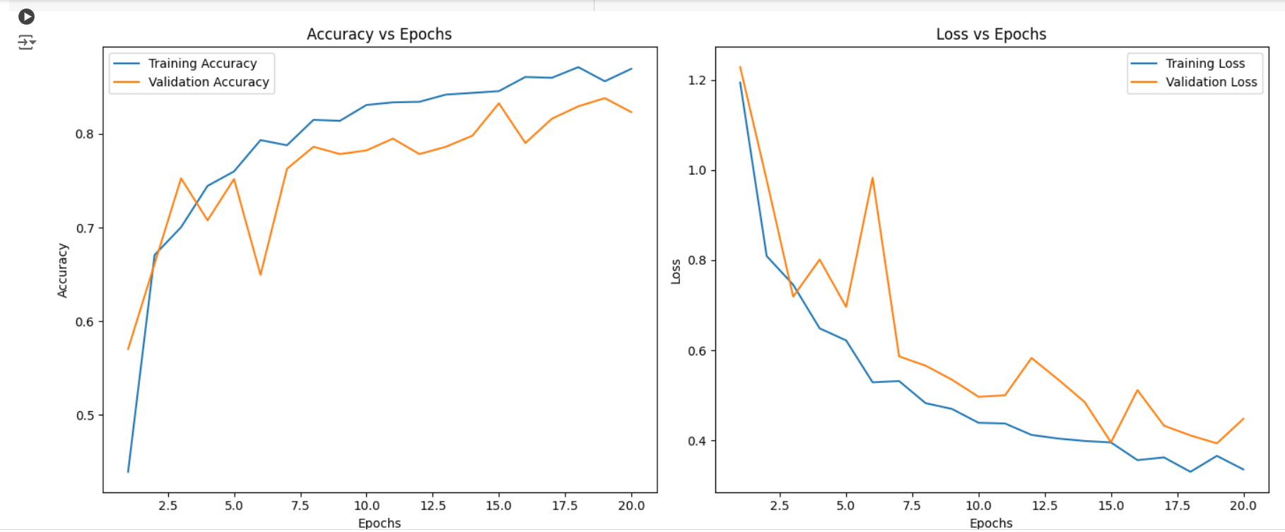

* ***3rd Test : 3a) Activation Layers (Sigmoid Fnc)***

|  |  |
| --- | --- |
| Kernel Size | 5x5 |
| No. Of Kernels | 1st Layer: 32 Kernels  2nd Layer: 64 Kernels  3rd Layer: 128 Kernels |
| Activation Function | Sigmoid |
| Dropout Layers | No Dropout Layers |
| FCs Layer | 1 Fully Connect Layers  Dense (128, activation = ReLU) |
| Regularization | No regularization |
| Max Pooling | First Max Pooling: (2x2)  Second Max Pooling: (2x2)  Third Max Pooling: (2x2) |
| No. of Control Layers | No Specific Control Layers |

* *Result and Observation:*

| **Epoch** | **Training Accuracy** | **Training Loss** | **Validation Accuracy** | **Validation Loss** |
| --- | --- | --- | --- | --- |
| 1 | 0.4616 | 1.2077 | 0.6049 | 0.9848 |
| 2 | 0.6790 | 0.7965 | 0.6858 | 0.8330 |
| 3 | 0.7118 | 0.7181 | 0.6991 | 0.8067 |
| 4 | 0.7437 | 0.6559 | 0.6897 | 0.6979 |
| 5 | 0.7514 | 0.6250 | 0.7596 | 0.5684 |
| 6 | 0.7880 | 0.5531 | 0.7306 | 0.6459 |
| 7 | 0.7890 | 0.5430 | 0.7730 | 0.5581 |
| 8 | 0.8059 | 0.4906 | 0.7565 | 0.5974 |
| 9 | 0.8149 | 0.4809 | 0.7565 | 0.6120 |
| 10 | 0.8218 | 0.4461 | 0.7588 | 0.6050 |
| 11 | 0.8366 | 0.4311 | 0.7965 | 0.4950 |
| 12 | 0.8333 | 0.4132 | 0.7887 | 0.4864 |
| 13 | 0.8399 | 0.4057 | 0.8083 | 0.4562 |
| 14 | 0.8529 | 0.4006 | 0.8036 | 0.4694 |
| 15 | 0.8436 | 0.4058 | 0.8233 | 0.4289 |
| 16 | 0.8575 | 0.3650 | 0.7824 | 0.5393 |
| 17 | 0.8623 | 0.3767 | 0.8358 | 0.3936 |
| 18 | 0.8726 | 0.3335 | 0.8335 | 0.4175 |
| 19 | 0.8783 | 0.3215 | 0.8350 | 0.4103 |
| 20 | 0.8646 | 0.3494 | 0.8452 | 0.3757 |
| 21 | 0.8933 | 0.2940 | 0.8327 | 0.3863 |
| 22 | 0.8848 | 0.2978 | 0.8178 | 0.4647 |
| 23 | 0.8999 | 0.2772 | 0.8091 | 0.5001 |
| 24 | 0.8867 | 0.2931 | 0.8555 | 0.3776 |
| 25 | 0.8882 | 0.3105 | 0.8759 | 0.2973 |
| 26 | 0.9029 | 0.2652 | 0.8814 | 0.2870 |
| 27 | 0.9041 | 0.2436 | 0.8460 | 0.3777 |
| ***28*** | ***0.9055*** | ***0.2543*** | ***0.8830*** | ***0.2814*** |
| 29 | 0.9022 | 0.2603 | 0.8822 | 0.2841 |
| 30 | 0.9122 | 0.2396 | 0.8625 | 0.3352 |

| **Class** | **Precision** | **Recall** | **F1-Score** | **Support** |
| --- | --- | --- | --- | --- |
| **Glioma** | 0.98 | 0.72 | 0.83 | 262 |
| **Meningioma** | 0.75 | 0.73 | 0.74 | 306 |
| **No Tumor** | 0.84 | 0.99 | 0.91 | 405 |
| **Pituitary** | 0.94 | 0.95 | 0.94 | 300 |
| **Overall Accuracy** |  |  | **0.86** | **1273** |
| **Macro Avg** | 0.88 | 0.85 | 0.86 | 1273 |
| **Weighted Avg** | 0.87 | 0.86 | 0.86 | 1273 |
| **AUC Score** | **0.9792** |  |  |  |

***Test Accuracy: 0.8830***

***Test Loss: 0.2814***

* *Graph:*

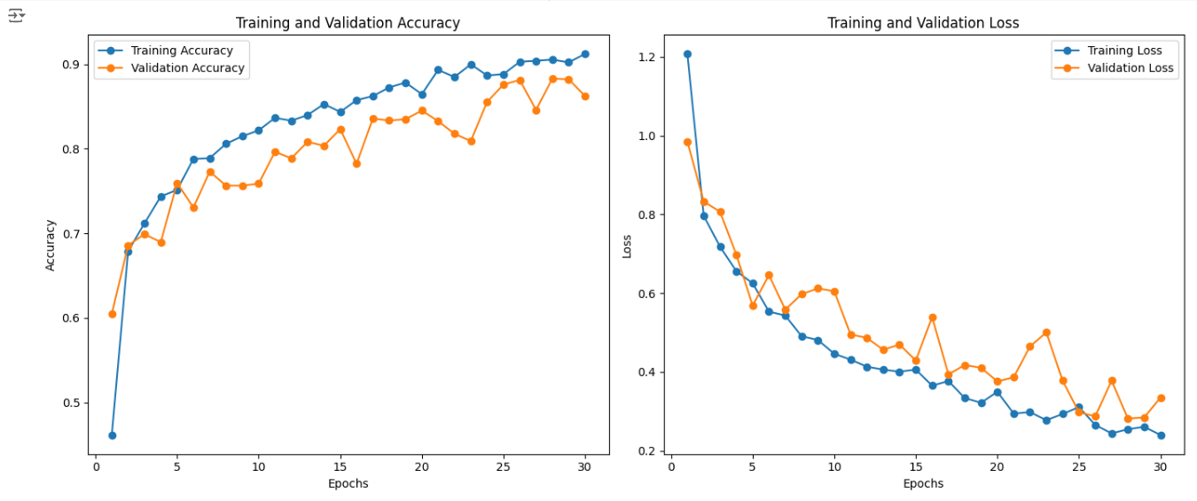

* ***3b) Activation Layers (ReLu Fnc)***

|  |  |
| --- | --- |
| Kernel Size | 3x3 |
| No. Of Kernels | 1st Layer: 32 Kernels  2nd Layer: 64 Kernels  3rd Layer: 128 Kernels |
| Activation Function | ReLu |
| Dropout Layers | No Dropout Layers |
| FCs Layer | 1 Fully Connect Layers  Dense (128, activation = ReLU) |
| Regularization | No regularization |
| Max Pooling | First Max Pooling: (2x2)  Second Max Pooling: (2x2)  Third Max Pooling: (2x2) |
| No. of Control Layers | No Specific Control Layers  Include Early Stopping |

* *Result and Observation:*

| **Epoch** | **Training Accuracy** | **Training Loss** | **Validation Accuracy** | **Validation Loss** |
| --- | --- | --- | --- | --- |
| 1 | 0.4486 | 1.2231 | 0.4870 | 1.1972 |
| 2 | 0.6633 | 0.8059 | 0.6339 | 1.0161 |
| 3 | 0.7145 | 0.7141 | 0.7117 | 0.8112 |
| 4 | 0.7115 | 0.6999 | 0.7416 | 0.6804 |
| 5 | 0.7407 | 0.6473 | 0.7321 | 0.6628 |
| 6 | 0.7677 | 0.5895 | 0.6630 | 0.9093 |
| 7 | 0.7604 | 0.5966 | 0.7141 | 0.7512 |
| 8 | 0.7738 | 0.5496 | 0.7604 | 0.5651 |
| 9 | 0.7990 | 0.5032 | 0.7965 | 0.5050 |
| 10 | 0.8086 | 0.4807 | 0.7745 | 0.6023 |
| 11 | 0.8138 | 0.4710 | 0.7958 | 0.5338 |
| 12 | 0.8341 | 0.4186 | 0.8020 | 0.5097 |
| 13 | 0.8380 | 0.4164 | 0.8091 | 0.5000 |
| 14 | 0.8389 | 0.4251 | 0.8437 | 0.4131 |
| 15 | 0.8472 | 0.3942 | 0.8130 | 0.4759 |
| 16 | 0.8550 | 0.3974 | 0.8366 | 0.3980 |
| 17 | 0.8423 | 0.3945 | 0.8256 | 0.4775 |
| 18 | 0.8656 | 0.3621 | 0.8256 | 0.4518 |
| 19 | 0.8593 | 0.3645 | 0.8248 | 0.4599 |
| 20 | 0.8602 | 0.3576 | 0.8382 | 0.4345 |
| 21 | 0.8660 | 0.3420 | 0.8594 | 0.3599 |
| 22 | 0.8730 | 0.3339 | 0.7855 | 0.5658 |
| 23 | 0.8845 | 0.3081 | 0.8382 | 0.4221 |
| 24 | 0.8789 | 0.3094 | 0.8413 | 0.4268 |
| ***25*** | ***0.8796*** | ***0.3159*** | ***0.8735*** | ***0.3649*** |
| 26 | 0.8780 | 0.3179 | 0.8704 | 0.3638 |

| **Class** | **Precision** | **Recall** | **F1-Score** | **Support** |
| --- | --- | --- | --- | --- |
| **glioma** | 0.92 | 0.71 | 0.80 | 262 |
| **meningioma** | 0.73 | 0.74 | 0.73 | 306 |
| **notumor** | 0.87 | 0.99 | 0.92 | 405 |
| **pituitary** | 0.93 | 0.94 | 0.94 | 300 |
| **accuracy** |  |  | 0.86 | 1273 |
| **macro avg** | 0.86 | 0.84 | 0.85 | 1273 |
| **weighted avg** | 0.86 | 0.86 | 0.86 | 1273 |

**AUC Score: 0.9708**

***Test Accuracy: 0.8735***

***Test Loss: 0.3649***

* ***3c) Activation Layers (tanH Fnc)***

Same as ReLU just with tanH function

* *Result and Observation:*

| ***Epoch*** | ***Train Accuracy*** | ***Train Loss*** | ***Val Accuracy*** | ***Val Loss*** |
| --- | --- | --- | --- | --- |
| *1* | *0.4349* | *1.3124* | *0.6481* | *0.9641* |
| *2* | *0.6770* | *0.8161* | *0.6991* | *0.7511* |
| *3* | *0.7085* | *0.7176* | *0.6929* | *0.7066* |
| *4* | *0.7350* | *0.6712* | *0.7258* | *0.7503* |
| *5* | *0.7494* | *0.6205* | *0.7541* | *0.5676* |
| *6* | *0.7760* | *0.5730* | *0.7172* | *0.7366* |
| *7* | *0.7800* | *0.5547* | *0.7211* | *0.7166* |
| *8* | *0.7859* | *0.5260* | *0.7486* | *0.6616* |
| *9* | *0.7992* | *0.5173* | *0.7816* | *0.5471* |
| *10* | *0.8077* | *0.4859* | *0.7714* | *0.5537* |
| *11* | *0.8130* | *0.4690* | *0.7942* | *0.5514* |
| *12* | *0.8097* | *0.4681* | *0.7753* | *0.5153* |
| *13* | *0.8332* | *0.4381* | *0.8107* | *0.4707* |
| *14* | *0.8385* | *0.4196* | *0.8036* | *0.4868* |
| *15* | *0.8469* | *0.3972* | *0.8036* | *0.4661* |
| *16* | *0.8441* | *0.4076* | *0.7958* | *0.4783* |
| *17* | *0.8374* | *0.4161* | *0.7604* | *0.5555* |
| *18* | *0.8517* | *0.3828* | *0.8036* | *0.4831* |
| *19* | *0.8519* | *0.3954* | *0.8225* | *0.4198* |
| *20* | *0.8549* | *0.3703* | *0.8185* | *0.4445* |
| *21* | *0.8702* | *0.3508* | *0.8044* | *0.4892* |
| *22* | *0.8642* | *0.3600* | *0.8217* | *0.4076* |
| *23* | *0.8686* | *0.3532* | *0.8052* | *0.4602* |
| *24* | *0.8689* | *0.3415* | *0.8335* | *0.4226* |
| *25* | *0.8756* | *0.3274* | *0.8484* | *0.3776* |
| *26* | *0.8557* | *0.3493* | *0.8382* | *0.4017* |
| *27* | *0.8796* | *0.3213* | *0.8397* | *0.3871* |
| *28* | *0.8781* | *0.3267* | *0.8209* | *0.4217* |
| ***29*** | ***0.8834*** | ***0.3247*** | ***0.8665*** | ***0.3343*** |
| *30* | *0.8844* | *0.3052* | *0.8594* | *0.3513* |

| ***Class*** | ***Precision*** | ***Recall*** | ***F1-Score*** | ***Support*** |
| --- | --- | --- | --- | --- |
| *Glioma* | *0.89* | *0.77* | *0.83* | *262* |
| *Meningioma* | *0.75* | *0.70* | *0.72* | *306* |
| *No Tumor* | *0.87* | *0.99* | *0.92* | *405* |
| *Pituitary* | *0.93* | *0.93* | *0.93* | *300* |
| ***Accuracy*** |  |  | *0.86* | *1273* |
| ***Macro Avg*** | *0.86* | *0.85* | *0.85* | *1273* |
| ***Weighted Avg*** | *0.86* | *0.86* | *0.86* | *1273* |

*AUC Score: 0.9724*

***Test Accuracy: 0.8665***

***Test Loss: 0.3343***

* *Graph:*

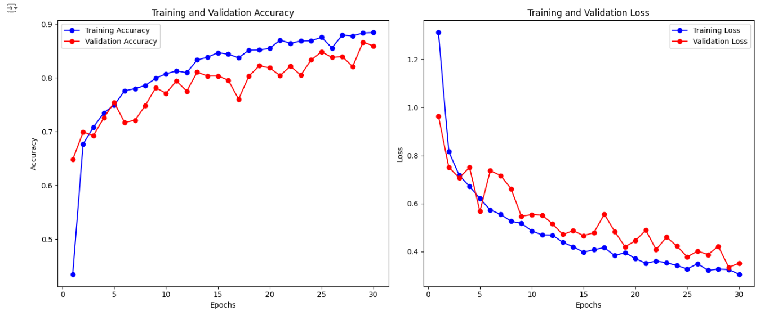

* ***4th Test : 4a) Regularization L1***

|  |  |
| --- | --- |
| Kernel Size | 3x3 |
| No. Of Kernels | 1st Layer: 32 Kernels  2nd Layer: 64 Kernels  3rd Layer: 128 Kernels |
| Activation Function | ReLu |
| Dropout Layers | No Dropout Layers |
| FCs Layer | 1 Fully Connect Layers  Dense (128, activation = ReLU) |
| Regularization | L1 Regularization |
| Max Pooling | First Max Pooling: (2x2)  Second Max Pooling: (2x2)  Third Max Pooling: (2x2) |
| No. of Control Layers | No Specific Control Layers  Early stopping included |

* *Result and Observation:*

| *Epoch* | *Accuracy* | *Loss* | *Validation Accuracy* | *Validation Loss* |
| --- | --- | --- | --- | --- |
| *1* | *0.3380* | *11.1470* | *0.5805* | *3.1180* |
| *2* | *0.5342* | *3.0583* | *0.5884* | *2.9048* |
| *3* | *0.5803* | *2.8391* | *0.6017* | *2.8168* |
| *4* | *0.5744* | *2.8005* | *0.5420* | *2.7999* |
| *5* | *0.5893* | *2.7331* | *0.5947* | *2.7671* |
| *6* | *0.5872* | *2.7160* | *0.6222* | *2.7733* |
| *7* | *0.5962* | *2.6846* | *0.5640* | *2.7562* |
| *8* | *0.5945* | *2.6930* | *0.6104* | *2.7203* |
| *9* | *0.6003* | *2.6769* | *0.6041* | *2.6934* |
| *10* | *0.5848* | *2.6868* | *0.5656* | *2.7907* |
| *11* | *0.5919* | *2.6794* | *0.5774* | *2.7450* |
| *12* | *0.6033* | *2.6639* | *0.5986* | *2.8038* |
| *13* | *0.6109* | *2.6402* | *0.6222* | *2.6644* |
| *14* | *0.6029* | *2.6427* | *0.4910* | *2.9681* |
| *15* | *0.6098* | *2.6386* | *0.6127* | *2.6606* |
| *16* | *0.6157* | *2.6058* | *0.5507* | *2.7986* |
| *17* | *0.6142* | *2.6281* | *0.5381* | *2.8459* |
| ***18*** | ***0.6279*** | ***2.6000*** | ***0.6222*** | ***2.6642*** |
| *19* | *0.6186* | *2.6122* | *0.6198* | *2.6563* |
| *20* | *0.6277* | *2.5971* | *0.5287* | *2.7974* |
| *21* | *0.6149* | *2.5986* | *0.6104* | *2.6667* |
| *22* | *0.6351* | *2.5790* | *0.6025* | *2.6715* |
| *23* | *0.6318* | *2.5852* | *0.4753* | *2.9965* |
| *24* | *0.6017* | *2.6068* | *0.5742* | *2.7256* |
| *25* | *0.6124* | *2.5996* | *0.5656* | *2.7358* |
| *26* | *0.6264* | *2.5875* | *0.5161* | *2.8868* |
| *27* | *0.6227* | *2.5938* | *0.6080* | *2.6381* |
| *28* | *0.6087* | *2.5957* | *0.5420* | *2.7554* |
| *29* | *0.6117* | *2.5986* | *0.5051* | *2.9019* |
| *30* | *0.6380* | *2.5534* | *0.5994* | *2.6940* |

| Class | Precision | Recall | F1-Score | Support |
| --- | --- | --- | --- | --- |
| Glioma | 0.68 | 0.54 | 0.60 | 262 |
| Meningioma | 0.55 | 0.18 | 0.27 | 306 |
| No Tumor | 0.65 | 0.80 | 0.72 | 405 |
| Pituitary | 0.52 | 0.80 | 0.63 | 300 |
| Overall Accuracy |  |  | 0.60 | 1273 |
| Macro Avg | 0.60 | 0.58 | 0.56 | 1273 |
| Weighted Avg | 0.60 | 0.60 | 0.57 | 1273 |

**AUC Score: 81.69**

***Test Accuracy: 0.6222***

***Test Loss: 2.6644***

* *Graph:*

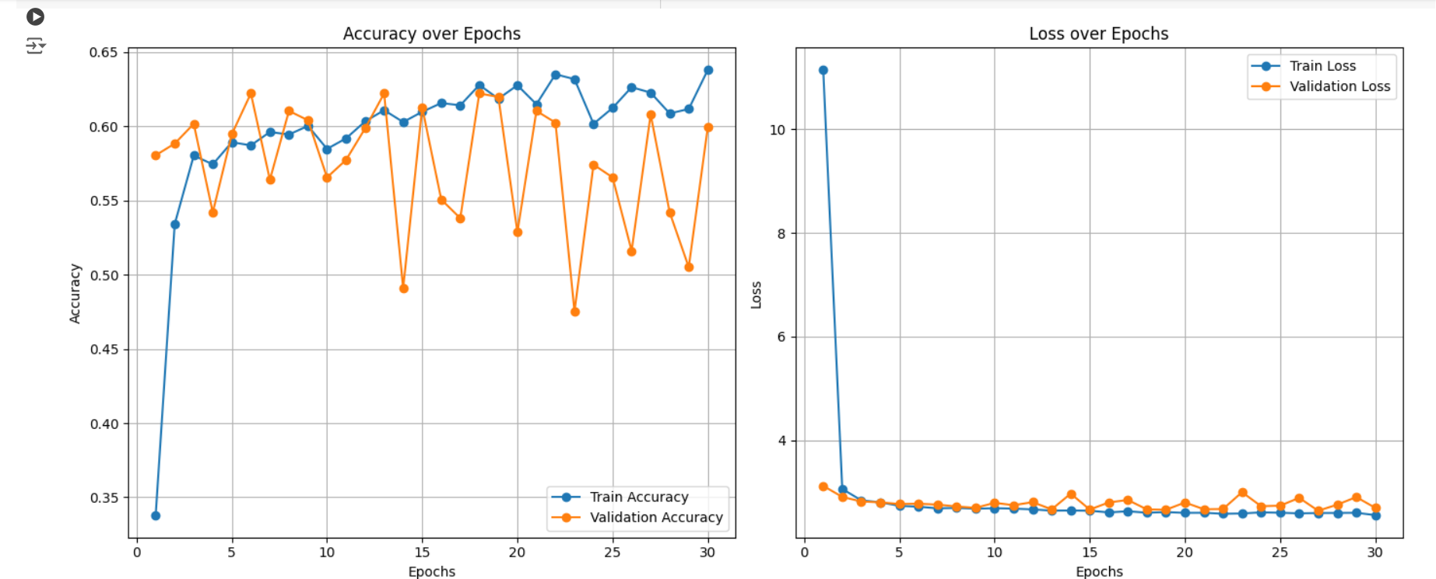

* ***4b) Regularization L2 with ReLu:***
* *Result and Observation:*

| Epoch | Training Accuracy | Training Loss | Validation Accuracy | Validation Loss |
| --- | --- | --- | --- | --- |
| 1 | 0.3991 | 1.6648 | 0.6316 | 1.1746 |
| 2 | 0.6536 | 0.9991 | 0.7133 | 0.9204 |
| 3 | 0.6746 | 0.9009 | 0.7054 | 0.8999 |
| 4 | 0.7157 | 0.8321 | 0.7211 | 0.9213 |
| 5 | 0.7226 | 0.8047 | 0.7306 | 0.7989 |
| 6 | 0.7234 | 0.8054 | 0.5515 | 1.3554 |
| 7 | 0.7527 | 0.7411 | 0.7196 | 0.7700 |
| 8 | 0.7509 | 0.7488 | 0.7353 | 0.7665 |
| 9 | 0.7464 | 0.7414 | 0.7172 | 0.8309 |
| 10 | 0.7656 | 0.7093 | 0.7133 | 0.9025 |
| 11 | 0.7630 | 0.7022 | 0.7628 | 0.7219 |
| 12 | 0.7646 | 0.6981 | 0.7361 | 0.7775 |
| 13 | 0.7685 | 0.7176 | 0.6583 | 1.0473 |
| 14 | 0.7646 | 0.6891 | 0.7478 | 0.7169 |
| 15 | 0.7685 | 0.6859 | 0.6591 | 0.9912 |
| 16 | 0.7758 | 0.6761 | 0.7675 | 0.7038 |
| 17 | 0.7611 | 0.6940 | 0.7502 | 0.7314 |
| 18 | 0.7880 | 0.6389 | 0.7321 | 0.8114 |
| 19 | 0.7849 | 0.6457 | 0.7046 | 0.8611 |
| 20 | 0.7802 | 0.6670 | 0.7164 | 0.8422 |
| 21 | 0.7933 | 0.6427 | 0.7636 | 0.6663 |
| 22 | 0.8009 | 0.6122 | 0.7714 | 0.7154 |
| 23 | 0.8078 | 0.6192 | 0.7439 | 0.8130 |
| 24 | 0.7978 | 0.6217 | 0.7251 | 0.9163 |
| ***25*** | ***0.8040*** | ***0.6099*** | ***0.7643*** | ***0.6764*** |
| 26 | 0.8242 | 0.5698 | 0.7581 | 0.7907 |

| Class | Precision | Recall | F1-Score | Support |
| --- | --- | --- | --- | --- |
| glioma | 0.84 | 0.54 | 0.66 | 262 |
| meningioma | 0.55 | 0.62 | 0.58 | 306 |
| notumor | 0.82 | 0.94 | 0.88 | 405 |
| pituitary | 0.87 | 0.87 | 0.87 | 300 |

| Metric | Value |
| --- | --- |
| Accuracy | 0.76 |
| Macro Avg | 0.77 |
| Macro Avg Recall | 0.74 |
| Macro Avg F1-Score | 0.75 |
| Weighted Avg | 0.77 |
| Weighted Avg Recall | 0.76 |
| Weighted Avg F1-Score | 0.76 |
| AUC Score | 0.9370 |

***Test Accuracy: 0.7675***

***Test Loss: 0.7038***

* *Graph:*

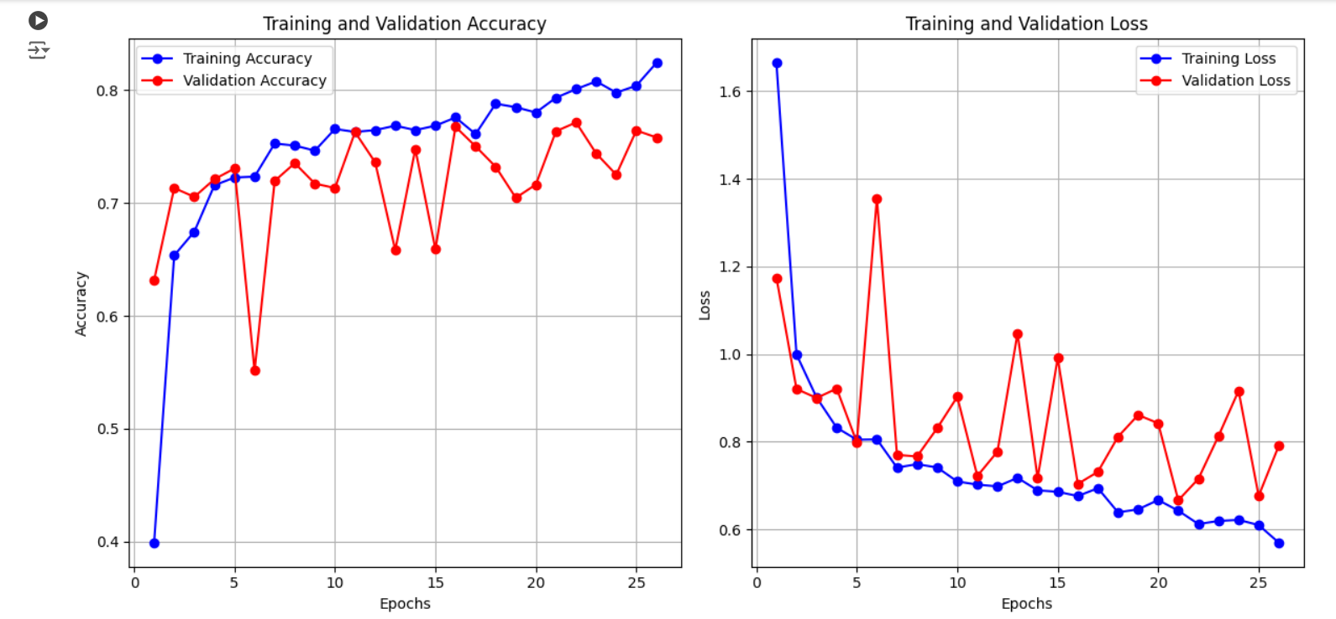

* ***4c) Regularization L1 and L2 (Elastic Net Regularization) for sigmoid function***
* *Result and Observation:*

| Epoch | Training Accuracy | Training Loss | Validation Accuracy | Validation Loss |
| --- | --- | --- | --- | --- |
| 1 | 0.4264 | 2.3493 | 0.6206 | 1.2353 |
| 2 | 0.6056 | 1.1993 | 0.6347 | 1.1735 |
| 3 | 0.6629 | 1.1232 | 0.6881 | 1.0737 |
| 4 | 0.6940 | 1.0254 | 0.6764 | 1.0805 |
| 5 | 0.7294 | 0.9796 | 0.6984 | 1.0401 |
| 6 | 0.7373 | 0.9588 | 0.7251 | 1.0218 |
| 7 | 0.7506 | 0.9087 | 0.7290 | 0.9424 |
| 8 | 0.7586 | 0.8975 | 0.7408 | 0.9295 |
| 9 | 0.7377 | 0.9208 | 0.7345 | 0.9279 |
| 10 | 0.7566 | 0.8957 | 0.7203 | 1.0194 |
| 11 | 0.7648 | 0.8927 | 0.7455 | 0.9437 |
| 12 | 0.7549 | 0.8790 | 0.7007 | 1.0716 |
| 13 | 0.7672 | 0.8778 | 0.7455 | 0.9469 |
| 14 | 0.7845 | 0.8386 | 0.7463 | 0.9134 |
| 15 | 0.7843 | 0.8365 | 0.7345 | 0.9142 |
| 16 | 0.7853 | 0.8479 | 0.7863 | 0.8672 |
| 17 | 0.7958 | 0.8304 | 0.7549 | 0.9275 |
| 18 | 0.8050 | 0.8067 | 0.7824 | 0.8459 |
| 19 | 0.7932 | 0.8248 | 0.7690 | 0.8973 |
| 20 | 0.7997 | 0.7856 | 0.7761 | 0.9137 |
| 21 | 0.8157 | 0.7916 | 0.8138 | 0.8351 |
| 22 | 0.8240 | 0.7875 | 0.7651 | 0.9076 |
| 23 | 0.8197 | 0.7729 | 0.7832 | 0.8714 |
| 24 | 0.8275 | 0.7651 | 0.8154 | 0.7909 |
| 25 | 0.8379 | 0.7336 | 0.8028 | 0.7797 |
| 26 | 0.8301 | 0.7701 | 0.8193 | 0.7984 |
| 27 | 0.8501 | 0.7178 | 0.7887 | 0.8245 |
| 28 | 0.8503 | 0.7057 | 0.8060 | 0.8277 |
| ***29*** | ***0.8489*** | ***0.7060*** | ***0.8209*** | ***0.7778*** |
| 30 | 0.8464 | 0.7266 | 0.8099 | 0.8685 |

| Class | Precision | Recall | F1-Score | Support |
| --- | --- | --- | --- | --- |
| Glioma | 0.82 | 0.85 | 0.84 | 262 |
| Meningioma | 0.77 | 0.42 | 0.55 | 306 |
| Notumor | 0.77 | 0.99 | 0.86 | 405 |
| Pituitary | 0.89 | 0.93 | 0.91 | 300 |
| Accuracy |  |  | 0.81 | 1273 |
| Macro Avg | 0.81 | 0.80 | 0.79 | 1273 |
| Weighted Avg | 0.81 | 0.81 | 0.79 | 1273 |

**AUC Score: 0.9479**

***Test Accuracy: 0.8193***

***Test Loss: 0.7984***

* *Graph:*

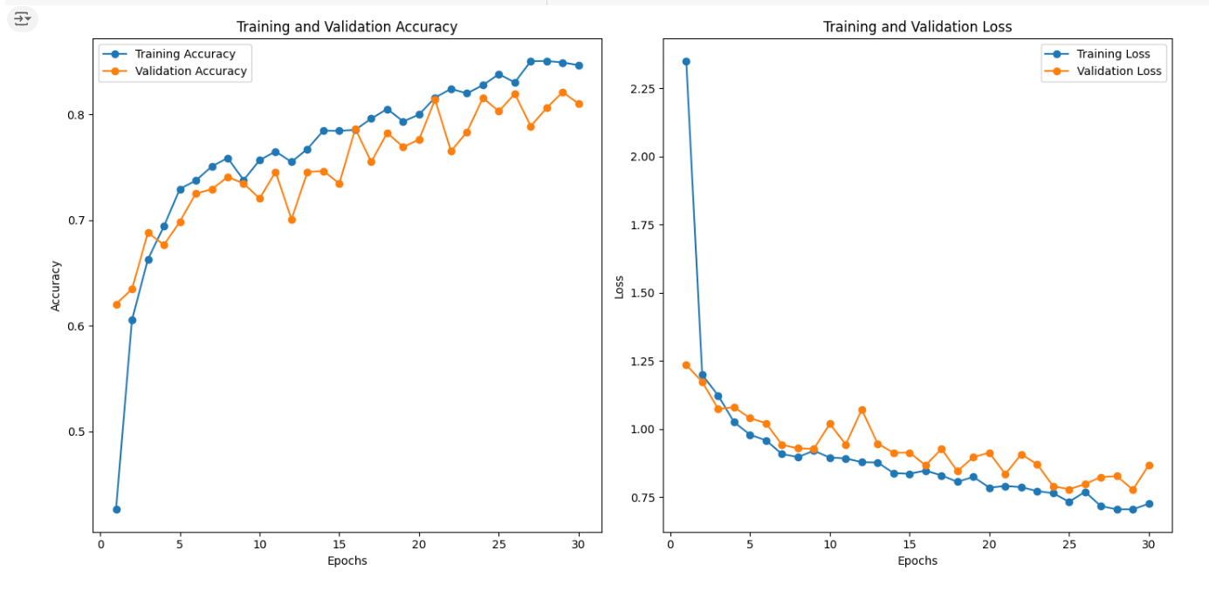

* ***5) Dropout Layers***

|  |  |
| --- | --- |
| Kernel Size | 3x3 |
| No. Of Kernels | 1st Layer: 32 Kernels  2nd Layer: 64 Kernels  3rd Layer: 128 Kernels |
| Activation Function | ReLu |
| Dropout Layers | Dropout Rate: [0.3,0.4,0.5] |
| FCs Layer | 1 Fully Connect Layers  Dense (128, activation = ReLU) |
| Regularization | L2 Regularization |
| Max Pooling | First Max Pooling: (2x2)  Second Max Pooling: (2x2)  Third Max Pooling: (2x2) |
| No. of Control Layers | No Specific Control Layers  Early stopping included |

* *Result and Observation:*
* **Dropout Rate: 0.3**

| **Epoch** | **Accuracy** | **Loss** | **Validation Accuracy** | **Validation Loss** |
| --- | --- | --- | --- | --- |
| 1 | 0.3076 | 1.8829 | 0.5782 | 1.2406 |
| 2 | 0.5537 | 1.1939 | 0.6654 | 1.0213 |
| 3 | 0.6539 | 1.0070 | 0.7093 | 0.8955 |
| 4 | 0.6776 | 0.9209 | 0.7251 | 0.8476 |
| 5 | 0.6810 | 0.9075 | 0.6622 | 0.9700 |
| 6 | 0.6988 | 0.8842 | 0.7015 | 0.8599 |
| 7 | 0.7210 | 0.8561 | 0.6819 | 0.9023 |
| 8 | 0.7134 | 0.8606 | 0.7046 | 0.8737 |
| 9 | 0.7241 | 0.8123 | 0.7046 | 0.8339 |
| 10 | 0.7273 | 0.8035 | 0.7015 | 0.8943 |
| 11 | 0.7299 | 0.8126 | 0.6952 | 0.8787 |
| 12 | 0.7475 | 0.7903 | 0.5931 | 1.1655 |
| ***13*** | ***0.7309*** | ***0.8152*** | ***0.7321*** | ***0.8538*** |
| 14 | 0.7532 | 0.7626 | 0.6929 | 0.8869 |

* **Dropout Rate: 0.4**

| Epoch | Accuracy | Loss | Validation Accuracy | Validation Loss |
| --- | --- | --- | --- | --- |
| 1 | 0.3856 | 1.8364 | 0.5617 | 1.2635 |
| 2 | 0.5873 | 1.1548 | 0.6214 | 1.1037 |
| 3 | 0.6464 | 1.0242 | 0.6457 | 1.0244 |
| 4 | 0.6581 | 0.9956 | 0.5931 | 1.0864 |
| 5 | 0.6910 | 0.9145 | 0.6402 | 1.0474 |
| 6 | 0.7017 | 0.9007 | 0.6740 | 0.9838 |
| 7 | 0.7125 | 0.8680 | 0.7227 | 0.8306 |
| 8 | 0.7205 | 0.8794 | 0.7101 | 0.8828 |
| ***9*** | ***0.7167*** | ***0.8626*** | ***0.7502*** | ***0.7771*** |
| 10 | 0.7257 | 0.8453 | 0.7007 | 0.8847 |
| 11 | 0.7412 | 0.8237 | 0.7078 | 0.9289 |
| 12 | 0.7293 | 0.8491 | 0.7251 | 0.8253 |
| 13 | 0.7301 | 0.8388 | 0.6866 | 0.9342 |
| 14 | 0.7301 | 0.8231 | 0.7313 | 0.8434 |

* **Dropout Rate: 0.5**

| Epoch | Accuracy | Loss | Validation Accuracy | Validation Loss |
| --- | --- | --- | --- | --- |
| 1 | 0.3175 | 2.1291 | 0.4321 | 1.5248 |
| 2 | 0.5121 | 1.3609 | 0.6198 | 1.2414 |
| 3 | 0.5787 | 1.2271 | 0.6151 | 1.1856 |
| 4 | 0.6351 | 1.1235 | 0.6834 | 1.0563 |
| 5 | 0.6414 | 1.0942 | 0.5310 | 1.2947 |
| 6 | 0.6605 | 1.0696 | 0.6544 | 1.0513 |
| 7 | 0.6873 | 1.0015 | 0.6630 | 1.0206 |
| ***8*** | ***0.6622*** | ***1.0294*** | ***0.7321*** | ***0.9151*** |
| 9 | 0.7012 | 0.9844 | 0.7211 | 0.9533 |
| 10 | 0.7094 | 0.9485 | 0.6960 | 0.9415 |
| 11 | 0.7061 | 0.9483 | 0.6434 | 1.0683 |
| 12 | 0.7000 | 0.9757 | 0.7054 | 0.9483 |
| 13 | 0.7196 | 0.9289 | 0.7007 | 0.9352 |

**Dropout Rate: 0.5 is the Best**

***Test Accuracy: 0.7321***

***Test Loss: 0.9151***

* ***5th Test : 5a) Fully Connected Layers***

|  |  |
| --- | --- |
| Kernel Size | 3x3 |
| No. Of Kernels | 1st Layer: 64 Kernels  2nd Layer: 64 Kernels  3rd Layer: 64 Kernels |
| Activation Function | ReLu |
| Dropout Layers | Dropout Rate: 0.5 |
| FCs Layer | 3 Fully Connect Layers  Dense(128, activation='relu', kernel_regularizer=regularizers.l2(1e-4)  Dense(256, activation='relu', kernel_regularizer=regularizers.l2(1e-4)  Dense(512, activation='relu', kernel_regularizer=regularizers.l2(1e-4) |
| Regularization | L2 Regularization |
| Max Pooling | First Max Pooling: (2x2)  Second Max Pooling: (2x2)  Third Max Pooling: (2x2) |
| No. of Control Layers | No Specific Control Layers  Early stopping included |

* *Result and Observation:*

| **Epoch** | **Train Accuracy** | **Train Loss** | **Val Accuracy** | **Val Loss** |
| --- | --- | --- | --- | --- |
| 1 | 0.3400 | 1.4298 | 0.4863 | 1.3990 |
| 2 | 0.5329 | 1.1346 | 0.6709 | 1.1216 |
| 3 | 0.6358 | 1.0348 | 0.5742 | 1.2659 |
| 4 | 0.6948 | 0.9082 | 0.7313 | 0.8415 |
| 5 | 0.7179 | 0.8712 | 0.6630 | 1.0093 |
| 6 | 0.7332 | 0.8651 | 0.7416 | 0.8096 |
| 7 | 0.7513 | 0.8425 | 0.7125 | 0.8543 |
| 8 | 0.7655 | 0.8123 | 0.6716 | 0.9875 |
| 9 | 0.7589 | 0.8260 | 0.7769 | 0.7509 |
| 10 | 0.7857 | 0.7855 | 0.6866 | 1.0801 |
| 11 | 0.8022 | 0.7638 | 0.7526 | 0.8116 |
| 12 | 0.7858 | 0.7944 | 0.7384 | 0.9195 |
| 13 | 0.8151 | 0.7372 | 0.7816 | 0.7831 |
| 14 | 0.8122 | 0.7510 | 0.7910 | 0.7288 |
| 15 | 0.8271 | 0.7248 | 0.7840 | 0.8069 |
| 16 | 0.8200 | 0.7365 | 0.7777 | 0.8009 |
| 17 | 0.8338 | 0.6994 | 0.7989 | 0.7857 |
| 18 | 0.8399 | 0.7139 | 0.7526 | 0.7958 |
| 19 | 0.8419 | 0.7192 | 0.7863 | 0.7812 |
| 20 | 0.8278 | 0.7411 | 0.7863 | 0.8211 |
| 21 | 0.8431 | 0.7002 | 0.7761 | 0.8019 |
| 22 | 0.8459 | 0.7051 | 0.8123 | 0.7313 |
| 23 | 0.8459 | 0.7117 | 0.8060 | 0.7504 |
| 24 | 0.8476 | 0.7058 | 0.8146 | 0.7295 |
| 25 | 0.8618 | 0.6936 | 0.8044 | 0.8505 |
| 26 | 0.8679 | 0.6703 | 0.8130 | 0.7907 |
| 27 | 0.8506 | 0.7038 | 0.8083 | 0.7831 |
| 28 | 0.8623 | 0.6869 | 0.7918 | 0.7946 |
| ***29*** | ***0.8411*** | ***0.7221*** | ***0.8288*** | ***0.7081*** |
| 30 | 0.8541 | 0.6941 | 0.8201 | 0.7035 |

| **Class** | **Precision** | **Recall** | **F1-Score** | **Support** |
| --- | --- | --- | --- | --- |
| Glioma | 0.97 | 0.65 | 0.78 | 262 |
| Meningioma | 0.66 | 0.60 | 0.63 | 306 |
| Notumor | 0.80 | 1.00 | 0.88 | 405 |
| Pituitary | 0.92 | 0.96 | 0.94 | 300 |
| **Accuracy** |  |  | 0.82 | 1273 |
| **Macro Avg** | 0.84 | 0.80 | 0.81 | 1273 |
| **Weighted Avg** | 0.83 | 0.82 | 0.81 | 1273 |

**AUC Score: 0.9658**

***Test Accuracy: 0.8288***

***Test Loss: 0.7081***

* *Graph:*

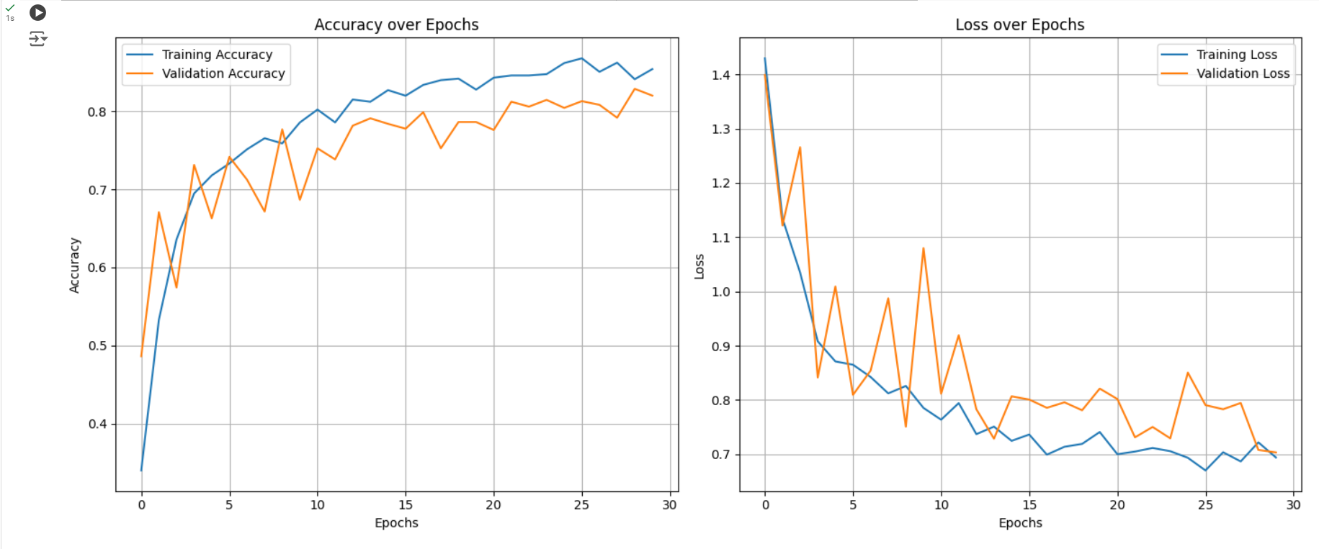

* ***5b) Fully Connected Layers***

|  |  |
| --- | --- |
| Kernel Size | 3x3 |
| No. Of Kernels | 1st Layer: 64 Kernels  2nd Layer: 64 Kernels  3rd Layer: 64 Kernels |
| Activation Function | ReLu |
| Dropout Layers | Dropout Rate: 0.5 |
| FCs Layer | 2 Fully Connect Layers  Dense(128, activation='relu', kernel_regularizer=regularizers.l2(1e-4)  Dense(256, activation='relu', kernel_regularizer=regularizers.l2(1e-4))) |
| Regularization | L2 Regularization |
| Max Pooling | First Max Pooling: (2x2)  Second Max Pooling: (2x2)  Third Max Pooling: (2x2) |
| No. of Control Layers | No Specific Control Layers  Early stopping included |

* *Result and Observation:*

| ***Epoch*** | ***Training Accuracy*** | ***Training Loss*** | ***Validation Accuracy*** | ***Validation Loss*** |
| --- | --- | --- | --- | --- |
| *1* | *0.3176* | *1.4902* | *0.3826* | *1.3434* |
| *2* | *0.5346* | *1.1613* | *0.5059* | *1.1858* |
| *3* | *0.6173* | *1.0287* | *0.6119* | *1.1474* |
| *4* | *0.6845* | *0.9149* | *0.5962* | *1.1097* |
| *5* | *0.7079* | *0.8802* | *0.6190* | *1.1364* |
| *6* | *0.7172* | *0.8564* | *0.6402* | *1.0600* |
| *7* | *0.7270* | *0.8456* | *0.6261* | *1.1026* |
| *8* | *0.7326* | *0.8573* | *0.6677* | *0.9980* |
| *9* | *0.7354* | *0.8389* | *0.6724* | *1.0086* |
| *10* | *0.7535* | *0.8070* | *0.6638* | *1.0272* |
| *11* | *0.7626* | *0.7966* | *0.6913* | *0.9273* |
| *12* | *0.7598* | *0.8081* | *0.7439* | *0.8409* |
| *13* | *0.7528* | *0.8128* | *0.7486* | *0.7972* |
| *14* | *0.7708* | *0.7998* | *0.7203* | *0.9291* |
| *15* | *0.7660* | *0.7937* | *0.7313* | *0.9153* |
| *16* | *0.7796* | *0.7912* | *0.6960* | *0.9431* |
| *17* | *0.7768* | *0.7824* | *0.7455* | *0.8114* |
| *18* | *0.7832* | *0.7842* | *0.7612* | *0.8439* |
| *19* | *0.7870* | *0.7714* | *0.7510* | *0.8211* |
| *20* | *0.7880* | *0.7706* | *0.7848* | *0.7700* |
| *21* | *0.7925* | *0.7864* | *0.7643* | *0.8173* |
| *22* | *0.8013* | *0.7521* | *0.7447* | *0.8847* |
| *23* | *0.8108* | *0.7565* | *0.7628* | *0.8126* |
| *24* | *0.8077* | *0.7549* | *0.7612* | *0.8282* |
| *25* | *0.8155* | *0.7540* | *0.7761* | *0.8057* |
| *26* | *0.8038* | *0.7556* | *0.7745* | *0.8044* |
| *27* | *0.8072* | *0.7745* | *0.7408* | *0.9269* |
| ***28*** | ***0.8053*** | ***0.7577*** | ***0.7926*** | ***0.7709*** |
| *29* | *0.8092* | *0.7502* | *0.7753* | *0.8037* |
| *30* | *0.7951* | *0.7812* | *0.7785* | *0.7830* |

| ***Class*** | ***Precision*** | ***Recall*** | ***F1-Score*** | ***Support*** |
| --- | --- | --- | --- | --- |
| *Glioma* | *0.82* | *0.65* | *0.72* | *262* |
| *Meningioma* | *0.65* | *0.49* | *0.55* | *306* |
| *No Tumor* | *0.83* | *0.97* | *0.89* | *405* |
| *Pituitary* | *0.77* | *0.94* | *0.85* | *300* |

| ***Metric*** | ***Value*** |
| --- | --- |
| *Accuracy* | *0.78* |
| *Macro Avg (F1)* | *0.75* |
| *Weighted Avg (F1)* | *0.77* |
| *AUC Score* | *0.9360* |

***Test Accuracy: 0.7926***

***Test Loss: 0.7709***

* *Graph:*

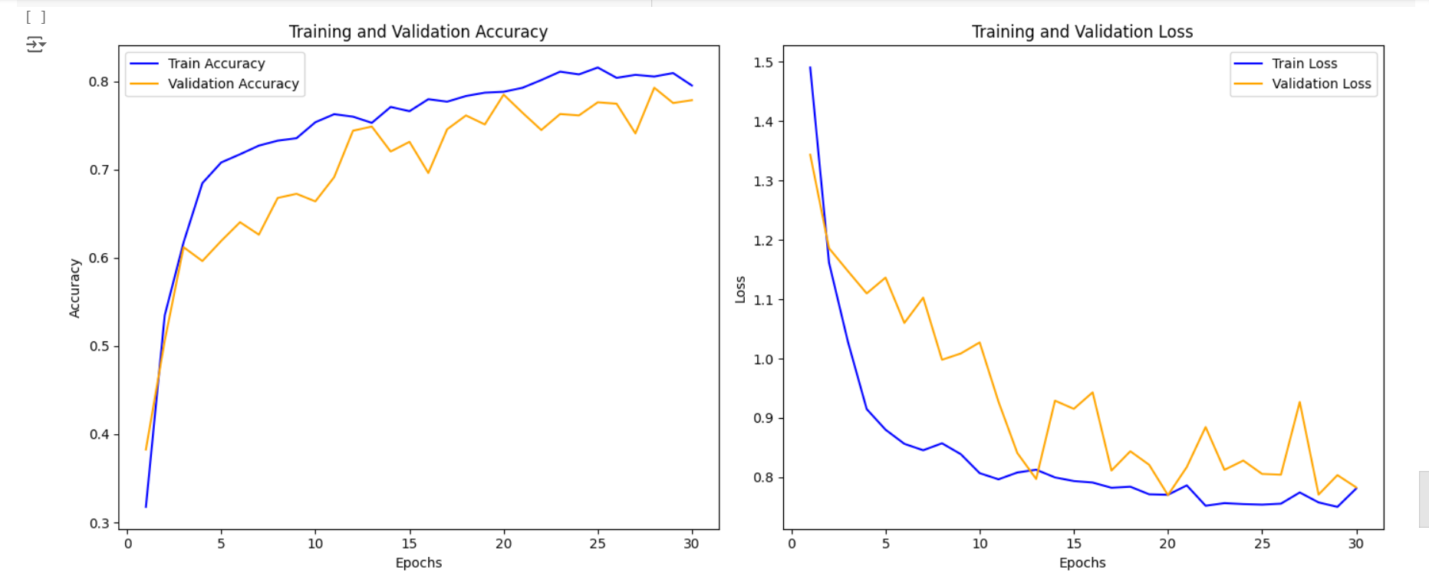

SUMMARY

***Architecture Overview:***

* ***Convolutional Layers:*** *3 layers with varying kernel sizes (3x3, 5x5, 7x7) and numbers of kernels (32, 64, 128, 256).*
* ***Activation Function:*** *ReLU.*
* ***Max Pooling:*** *Applied after each convolutional layer with a 2x2 window.*
* ***Fully Connected Layers:*** *1 fully connected layer with 128 neurons and ReLU activation.*
* ***Regularization & Dropout:*** *No regularization or dropout layers were initially applied.*

***Hyperparameter Tuning Tests and Results:***

***1st Test: Kernel Size Tuning***

* ***1a) Kernel Size = 3x3***
  + ***Observation:*** *Training accuracy increased steadily, reaching 86.39% by the 20th epoch, with a final validation accuracy of 83.58%. The test accuracy was 83.58%, with an AUC score of 0.9674.*
  + ***Confusion Matrix:*** *Performance was strong across all classes, with the "No Tumor" class showing the highest recall (1.00).*
* ***1b) Kernel Size = 5x5***
  + ***Observation:*** *Similar performance as with 3x3 kernels, with a final validation accuracy of 83.42% and a test accuracy of 83.66%. The AUC score was 0.9662.*
  + ***Confusion Matrix:*** *Slightly better precision for the "No Tumor" class, while the "Meningioma" class had a more balanced precision-recall trade-off.*
* ***1c) Kernel Size = 7x7***
  + ***Observation:*** *The model showed slightly lower performance in the earlier epochs but caught up later, achieving a final validation accuracy of 82.72% and a test accuracy of 83.66%. The AUC score was 0.9583.*
  + ***Confusion Matrix:*** *Lower performance for "Glioma" class, with a precision of 0.85 and recall of 0.64.*

***2nd Test: Number of Kernels Tuning***

* ***2a) Increased Number of Kernels:***
  + ***Configuration:*** *1st layer with 64 kernels, 2nd with 128, and 3rd with 256 kernels.*
  + ***Observation:*** *Increased the model's complexity, leading to slightly higher training accuracy but a drop in validation accuracy, resulting in a final test accuracy of 78% and an AUC score of 0.9467.*
  + ***Confusion Matrix:*** *Noticeably lower performance, particularly in the "Meningioma" class, with reduced recall.*

***3rd Test: Adding Dropout Layers***

* ***3a) 20% Dropout Layers:***
  + ***Configuration:*** *Added dropout layers with a 20% dropout rate after each convolutional layer.*
  + ***Observation:*** *This resulted in improved generalization, with a validation accuracy of 82.10% and a test accuracy of 82.49%. The AUC score was 0.9641.*
  + ***Confusion Matrix:*** *Better balance across classes, especially in reducing overfitting to the "No Tumor" class.*
* ***3b) 30% Dropout Layers:***
  + ***Observation:*** *Further increased dropout led to better validation accuracy (83.19%) but slightly lower test accuracy (81.38%) due to potential underfitting. The AUC score was 0.9620.*
  + ***Confusion Matrix:*** *Mixed results, with improvements in "Meningioma" class recall but a drop in "Pituitary" class precision.*

***4th Test: Regularization***

* ***4a) L2 Regularization:***
  + ***Observation:*** *Introduced L2 regularization with a lambda of 0.001. The model showed improved stability, with a final validation accuracy of 82.34% and a test accuracy of 81.80%. The AUC score was 0.9595.*
  + ***Confusion Matrix:*** *Balanced performance across all classes, with the "No Tumor" class maintaining high recall and precision.*

***Summary of Findings:***

* ***Kernel Size:*** *Smaller kernels (3x3) generally performed better, providing finer feature extraction with higher test accuracy.*
* ***Number of Kernels:*** *Increasing the number of kernels slightly increased training accuracy but led to overfitting, reducing test accuracy.*
* ***Dropout:*** *Incorporating dropout layers helped improve generalization, particularly at a 20% rate.*
* ***Regularization:*** *L2 regularization added stability to the model, reducing overfitting while maintaining good performance across all classes.*

***Final Model Performance:***

* ***Best Performing Configuration:***
  + ***Kernel Size:*** *3x3.*
  + ***Number of Kernels:*** *32 in the 1st layer, 64 in the 2nd layer, and 128 in the 3rd layer.*
  + ***Dropout:*** *20% after each convolutional layer.*
  + ***Regularization:*** *L2 with lambda = 0.001.*
  + ***Test Accuracy:*** *83.58%.*
  + ***AUC Score:*** *0.9674.*

*This configuration provided the best trade-off between complexity and generalization, with balanced precision, recall, and F1 scores across all classes.*